LAKE SUPERIOR HIKE: NORTH COUNTRY TRAIL HIKE 2 MILES
SAT. OCT. 3 1000 am Heritage Chapter.
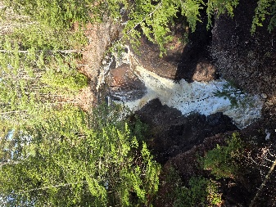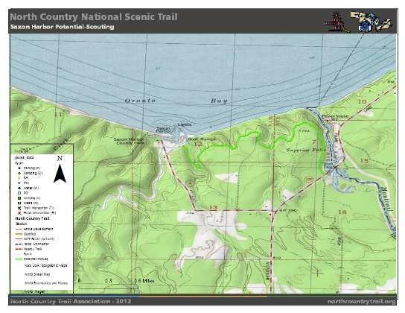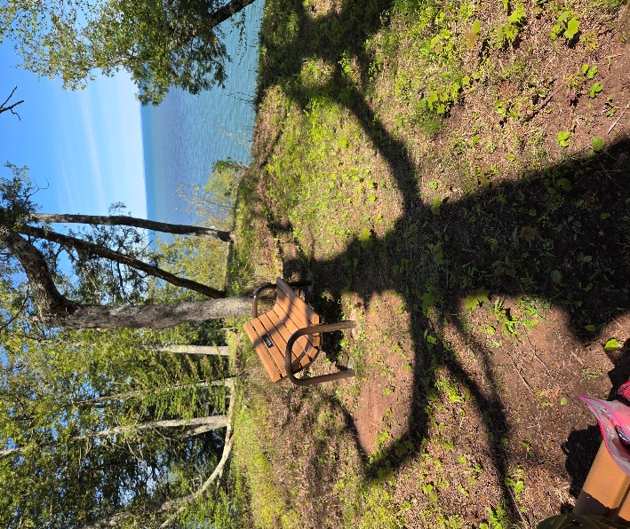
Leader: Bethany Thomas, Wisconsin Master Naturalist, President Heritage Chapter
Directions: From Hurley WI: Take US 2 to HWY 122 turn right,(North) just before Montreal River park on side of road. Follow event signs . Bring a snacks and wear what you will be comfortable in. This is an in and back hike. Questions: sally65bones@gmail.com .

